**PROJECT TITLE :**

**GARAGE MANAGEMENT SYSTEM**

**College Name :** Sri Vasavi College,

Erode-638316

**College Code :** bru17

**TEAM ID :** NM2025TMID23267

**TEAM MEMBERS :** 4

* Team Leader Name: SANJANA R
* Email: [sanjanarajup@gmail.com](mailto:sanjanarajup@gmail.com)
* Team Member1: PRASANTHI SRI M
* Email : [pprasanthisri@gmail.com](mailto:pprasanthisri@gmail.com)
* Team Member2: PARAMESHWARI M
* Email : [parameshwarim211@gmail.com](mailto:parameshwarim211@gmail.com)
* Team Member3: BABITHA M
* Email : [babitham215@gmail.com](mailto:babitham215@gmail.com)

# **1.INTRODUCTION**

1.1 Project Overview

The Garage Management System (GMS) helps garages manage customer details, vehicles, and services in one place. It reduces manual work by tracking repairs, spare parts, and billing digitally. This system improves efficiency, accuracy, and customer satisfaction.

**GARAGE**

**MANAGEMENT**

**SYSTEM**

CUSTOMER

MANAGEMENT

REPAIR & SERVICE

MANAGEMENT

VEHICLE

MANAGEMENT

INVENTORY

MANAGEMERT

## **1.2 Purpose**

The Garage Management System streamlines operations by digitally managing customer, vehicle, and service details. It reduces manual work, improving efficiency, accuracy, and customer satisfaction.

## DEVELOPMENT PHASE

Creating Developer Account:

* By using this URL : - [**https://developer.salesforce.com/signup**](https://developer.salesforce.com/signup)

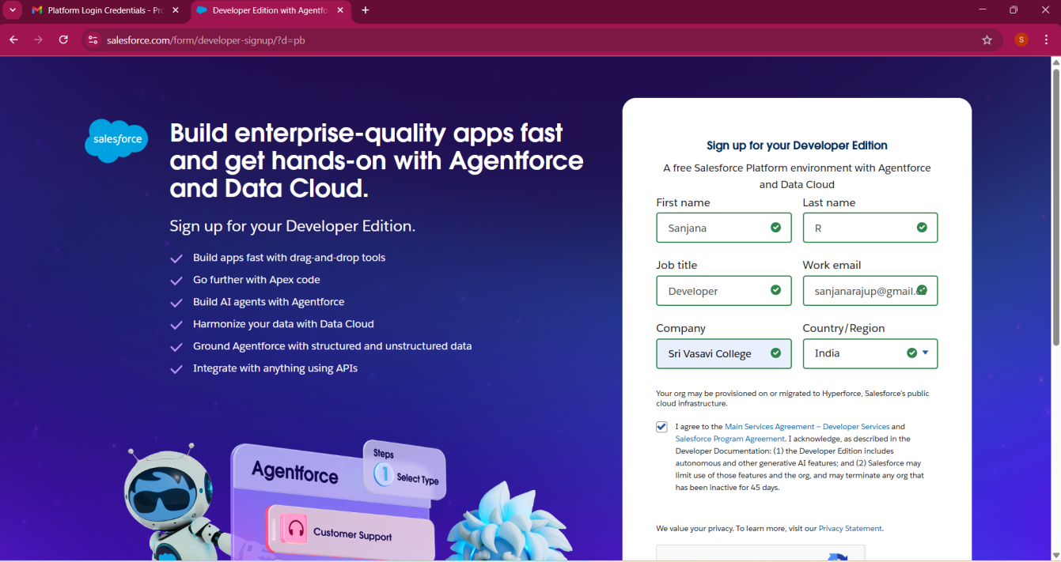

* Create objects: Customer Details, Appointment, Service records, Billing details and feedback.

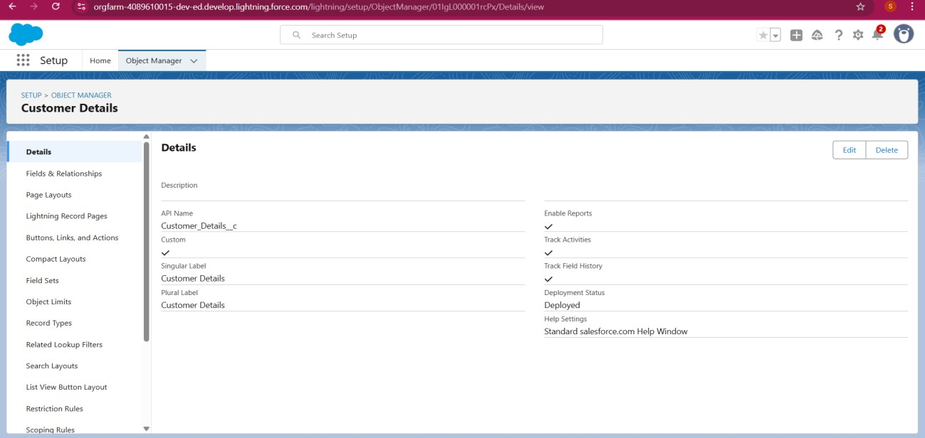

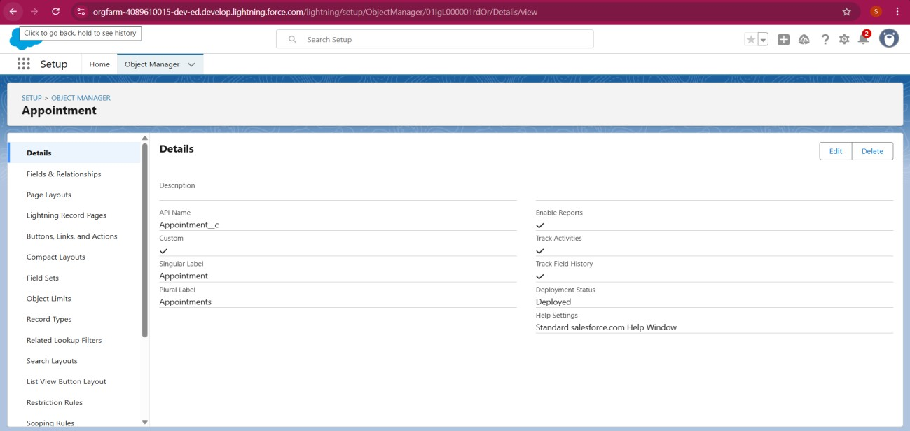

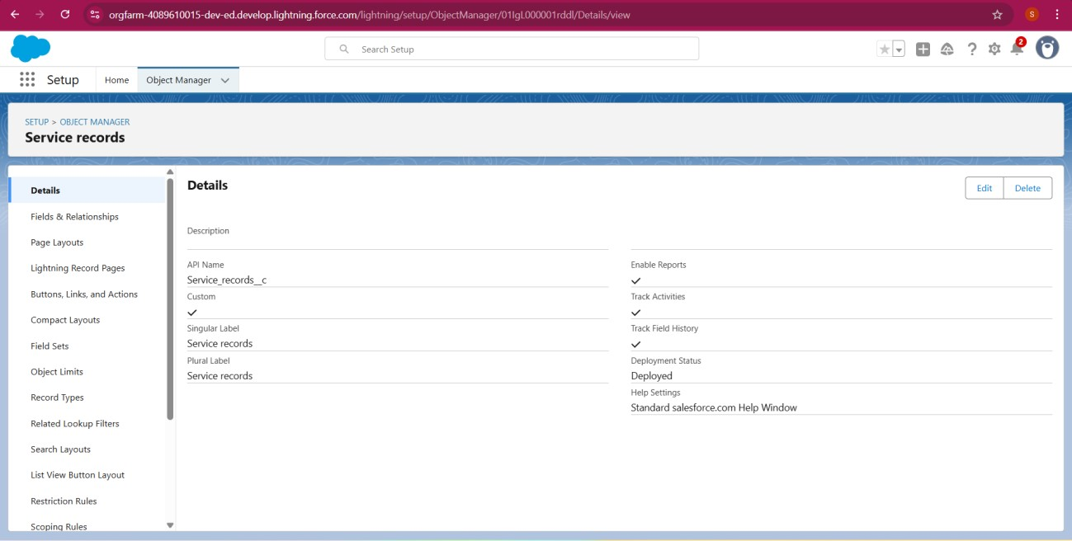

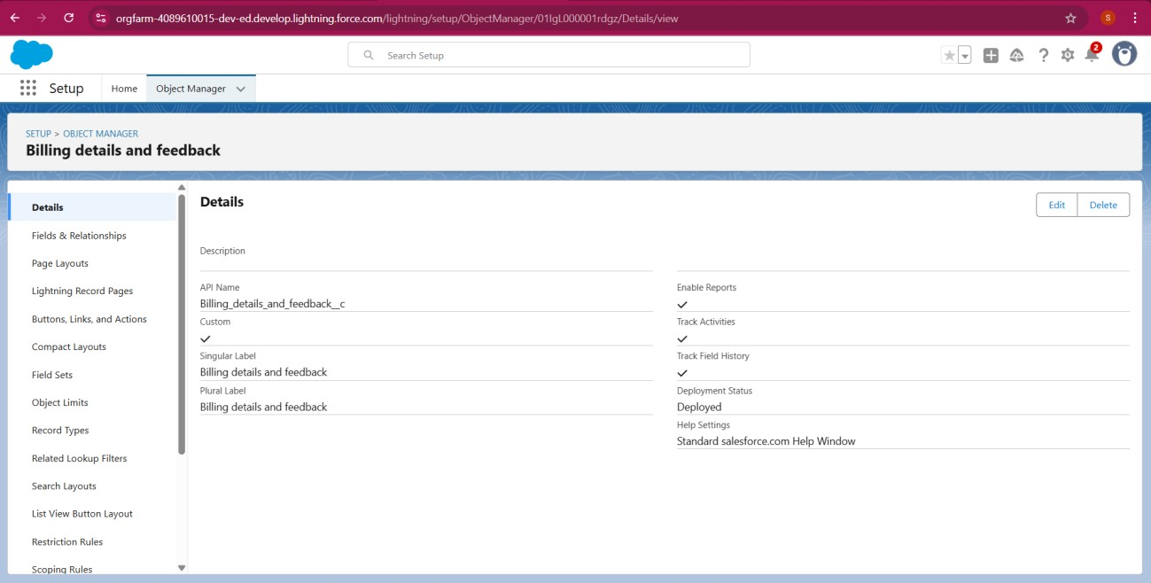

* Created Tabs : Customer Details, Appoinment ,Service records, Billing details and feedback.

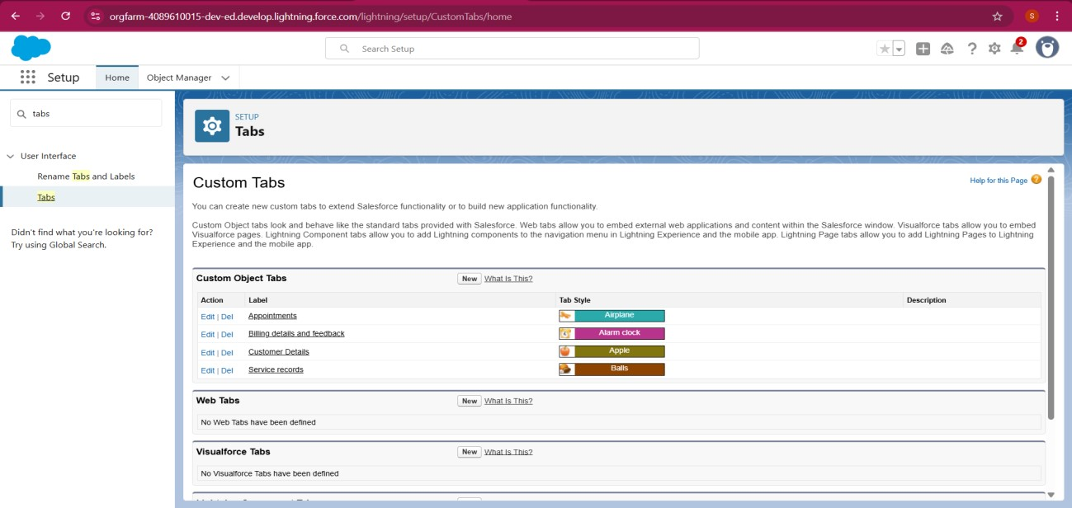

* Developed Lightning App with relevant tabs

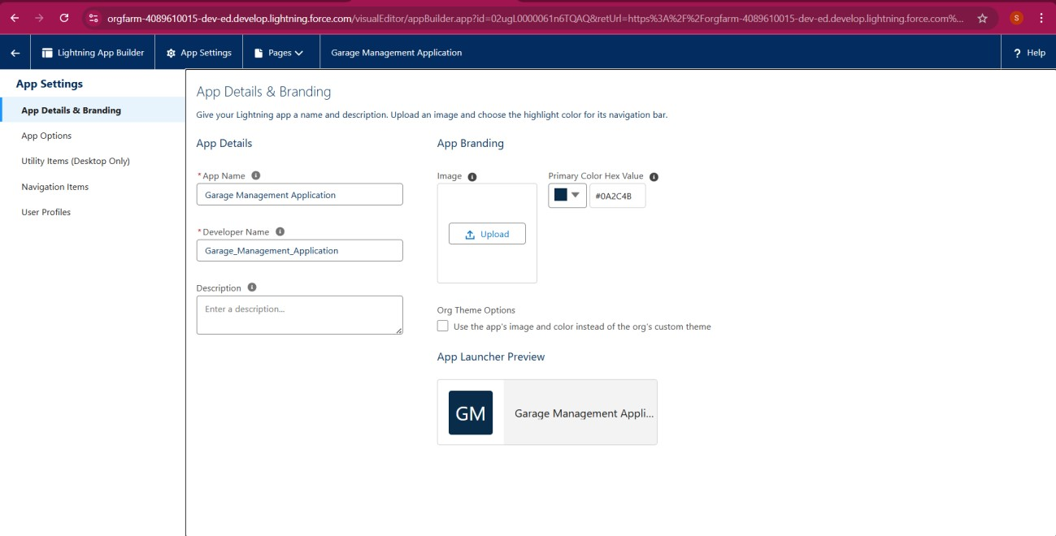

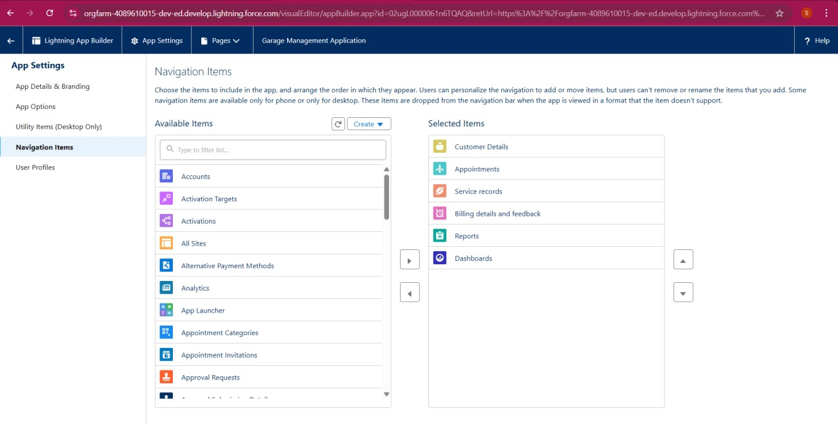

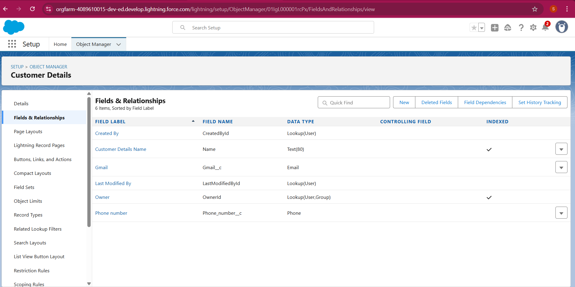Configured Fields and Relationships

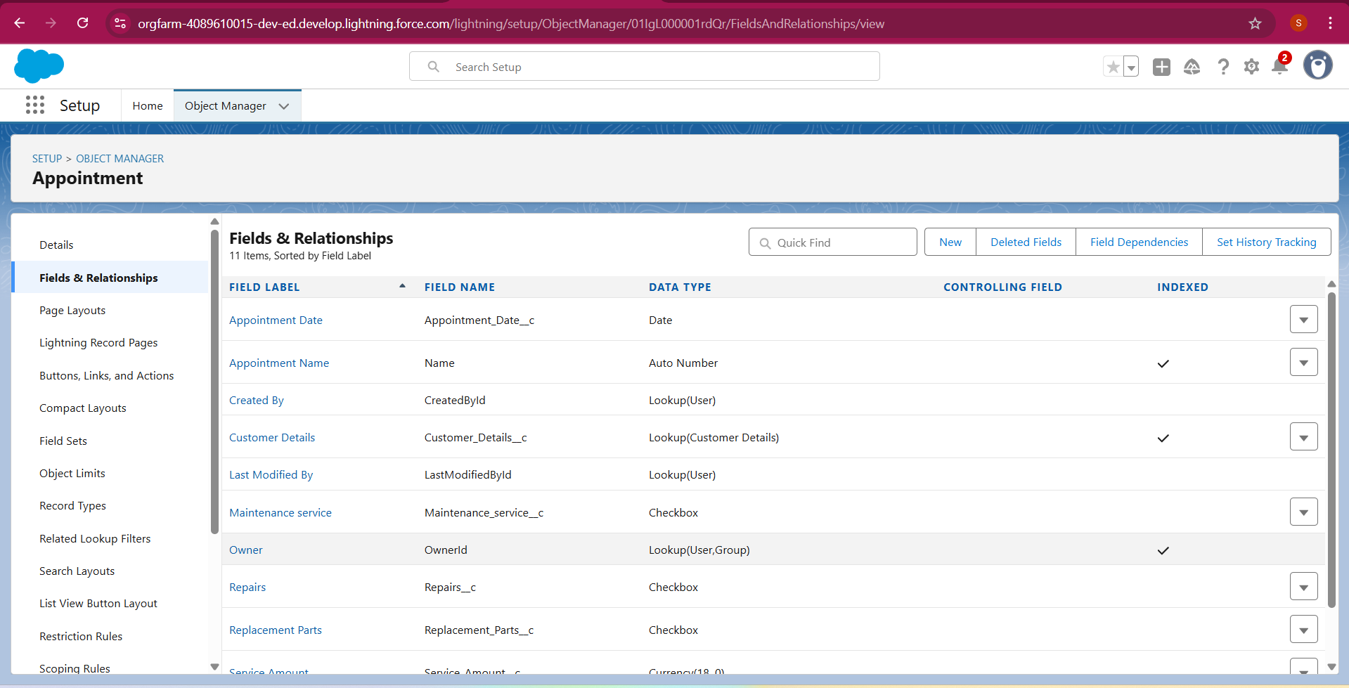

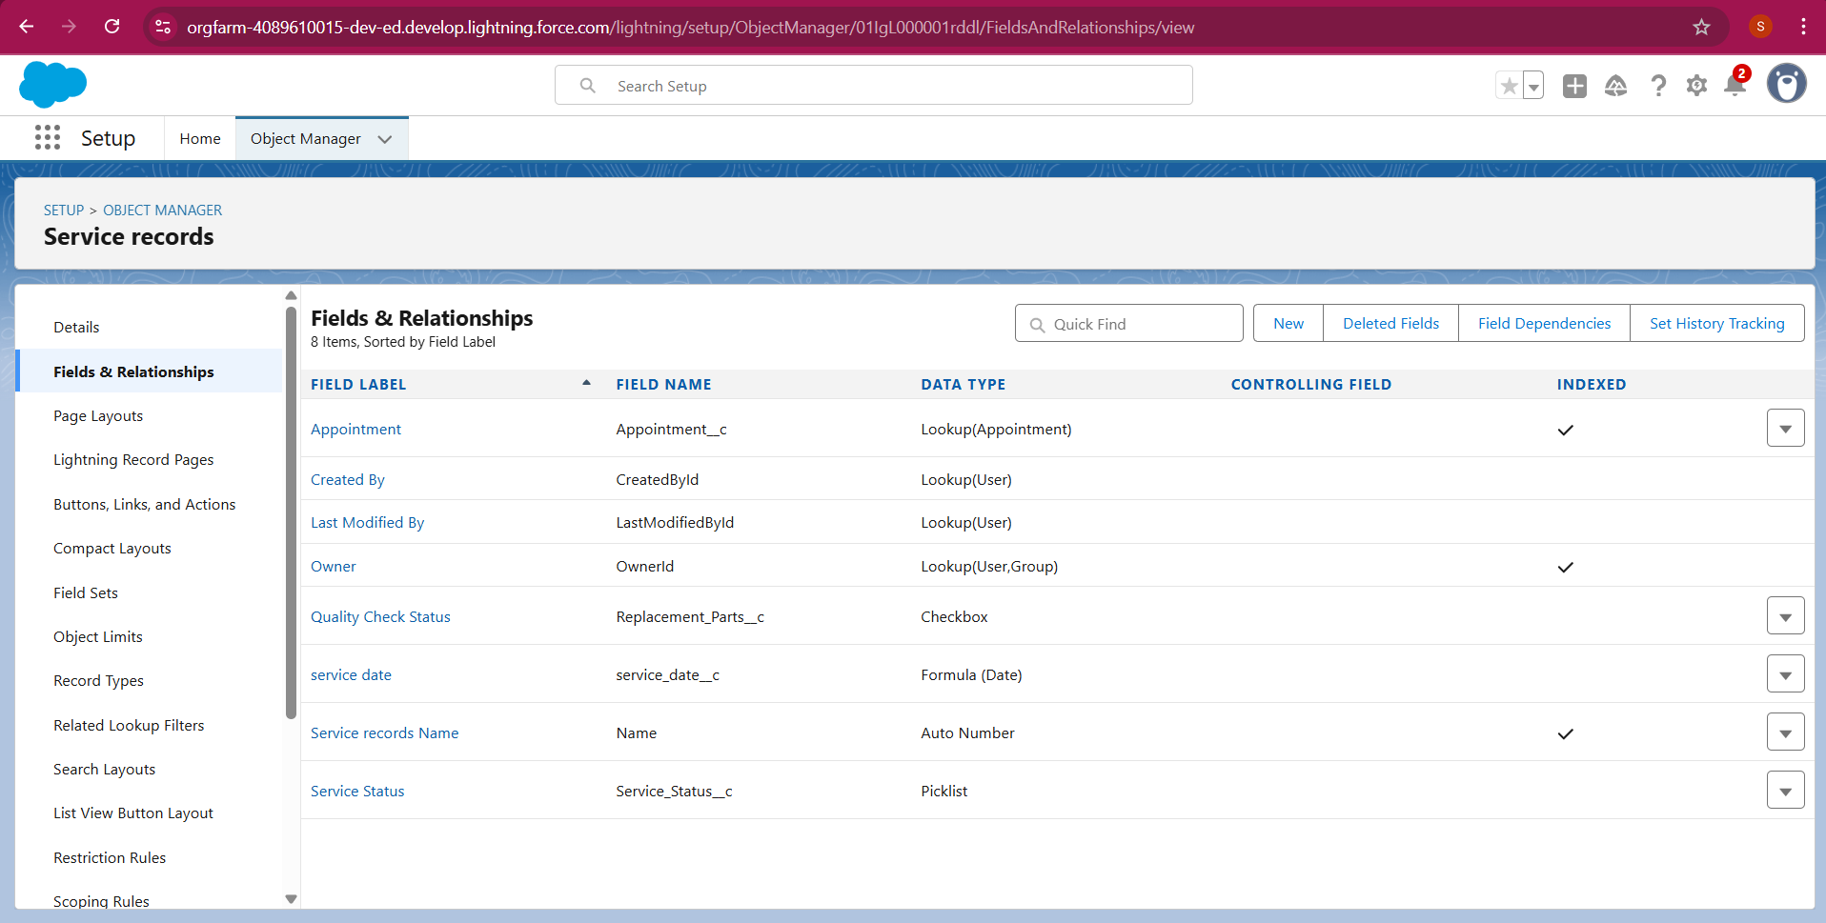

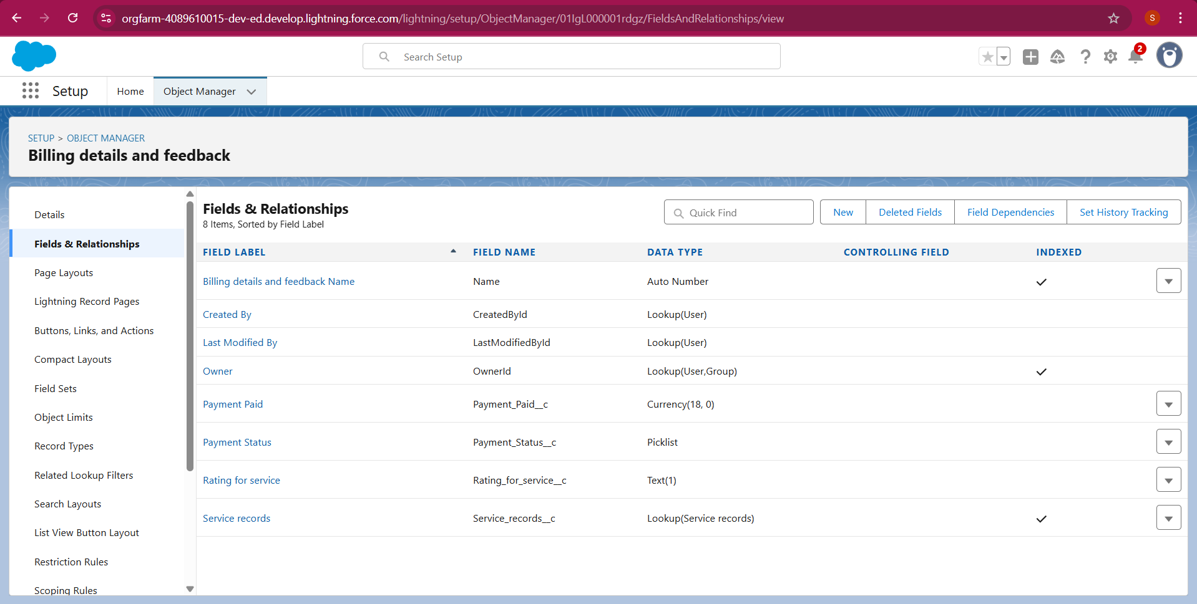

### Created a validation rule to an Appointment Object and Billing details and feedback Object

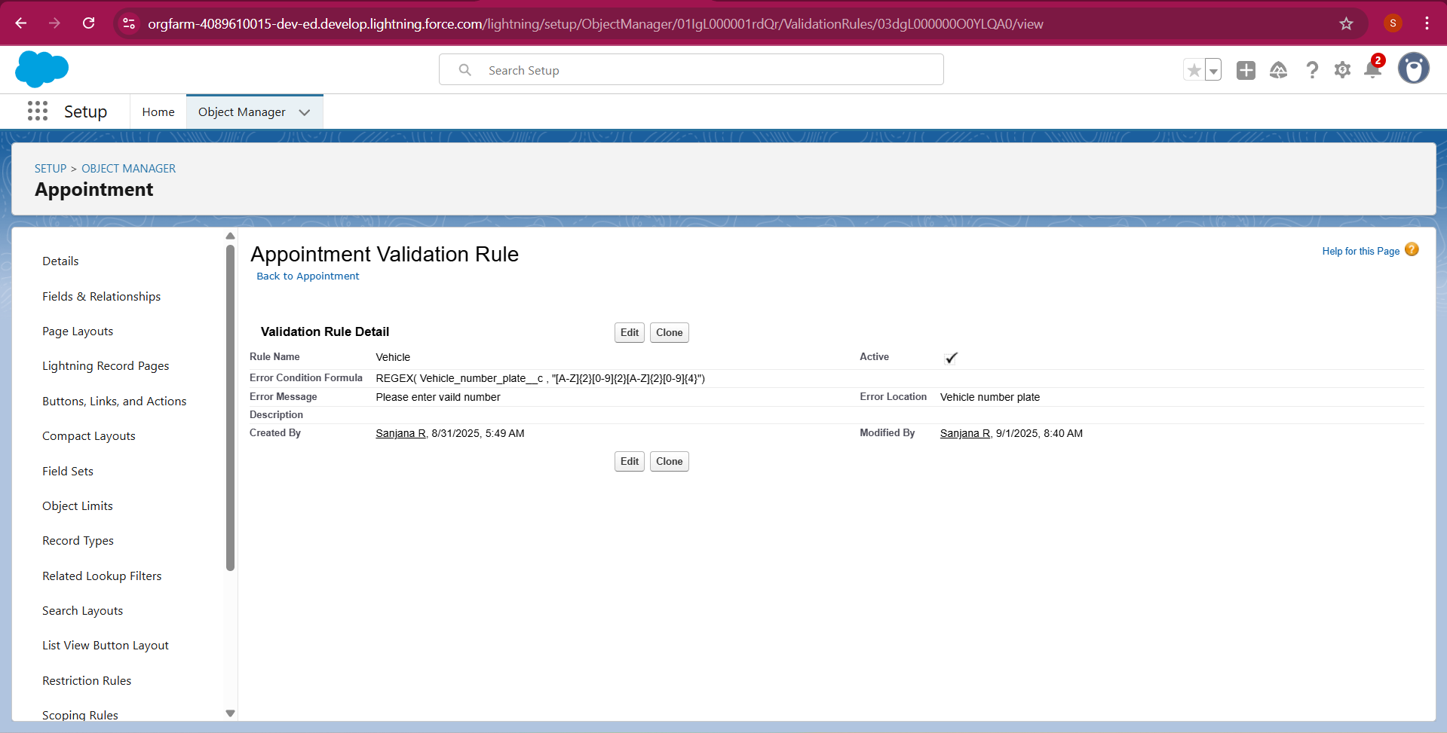

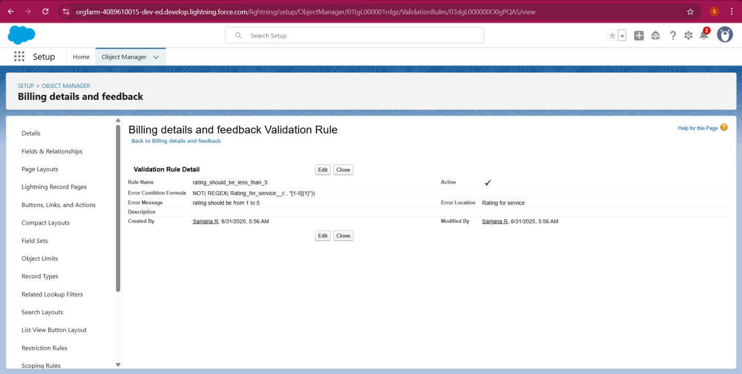

### Created a matching rule to an Customer details Object

### Created a Duplicate rule to an Customer details Object

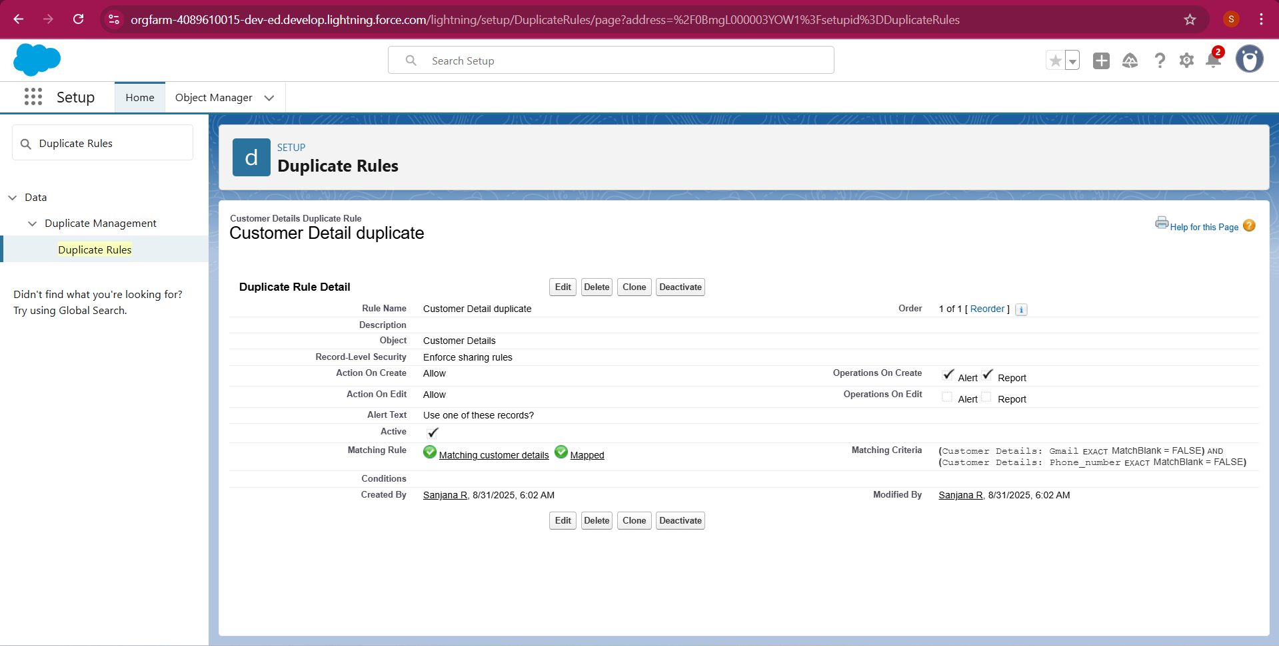

* Created ProfileS

Manager Profile

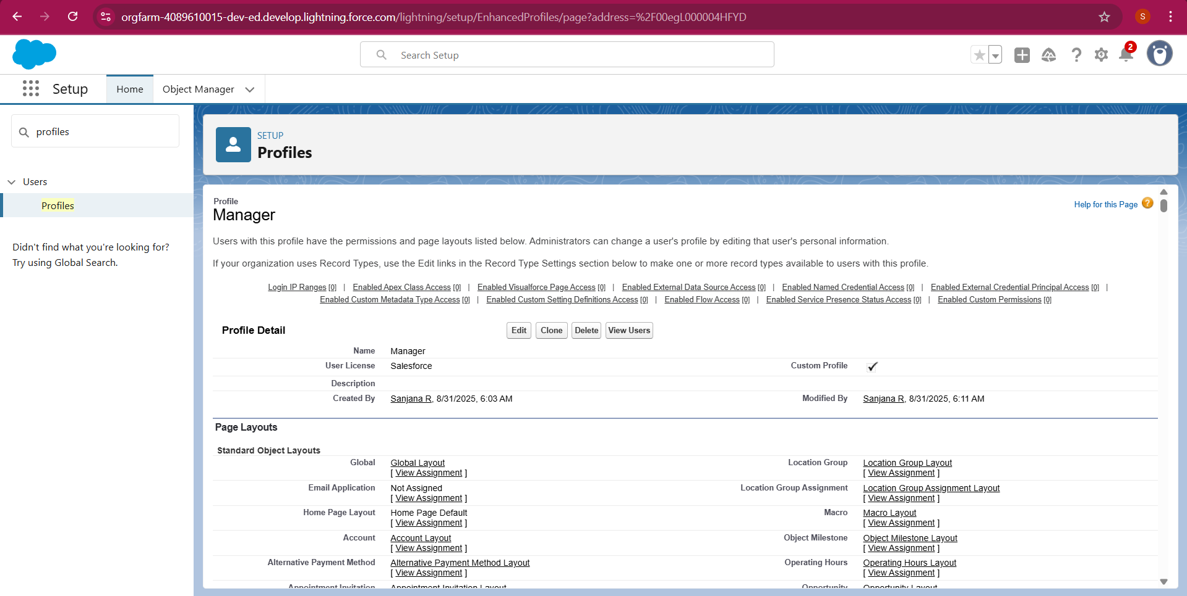

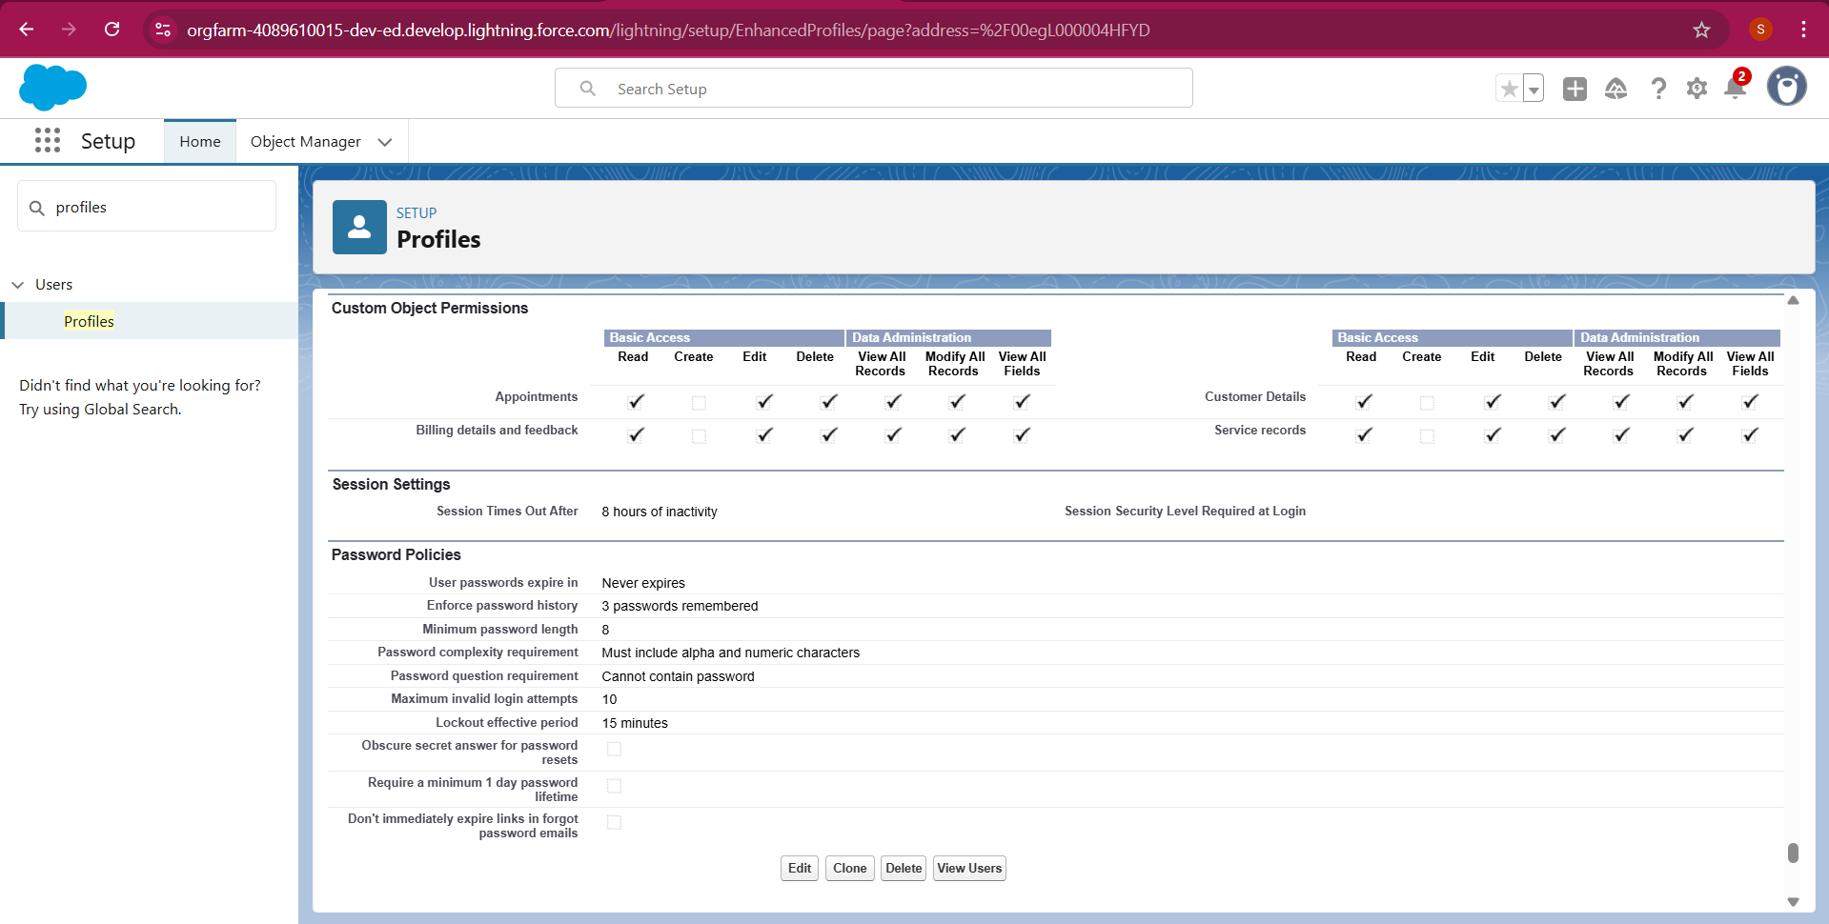

Sales Person Profile

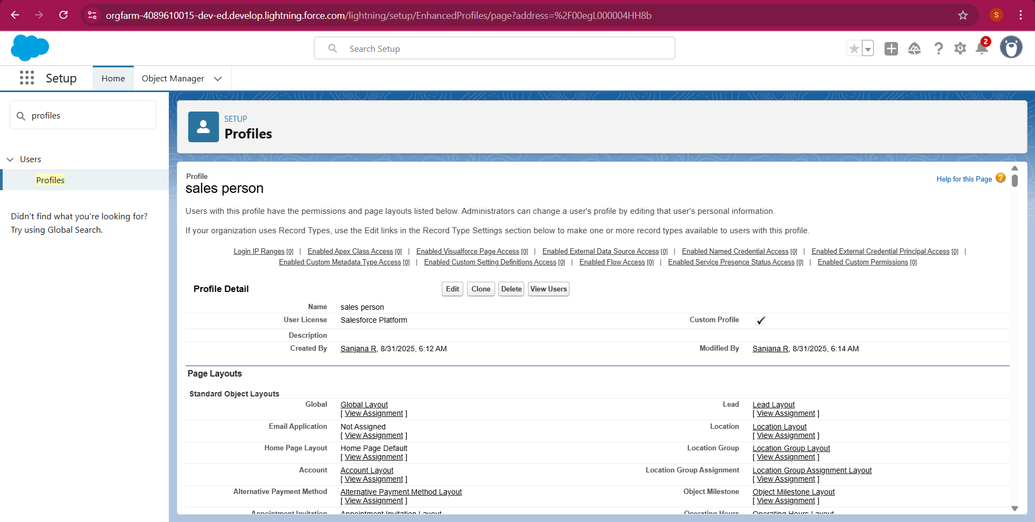

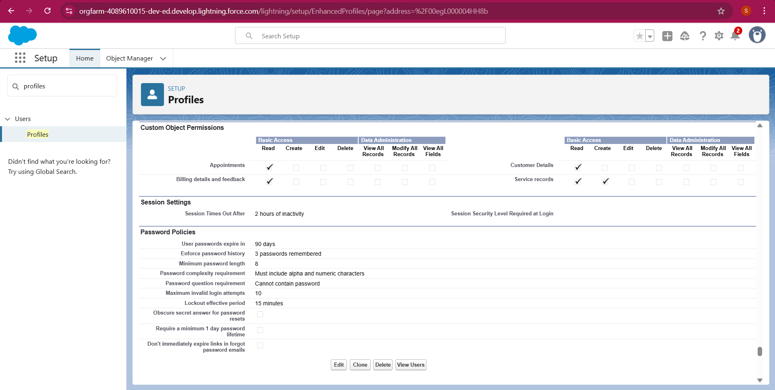

* Created a manager role

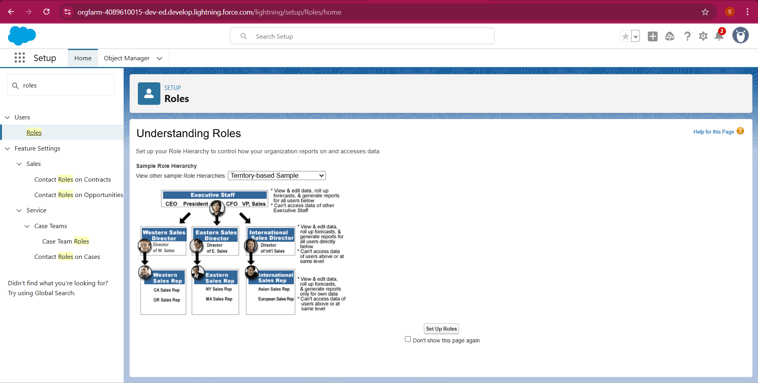

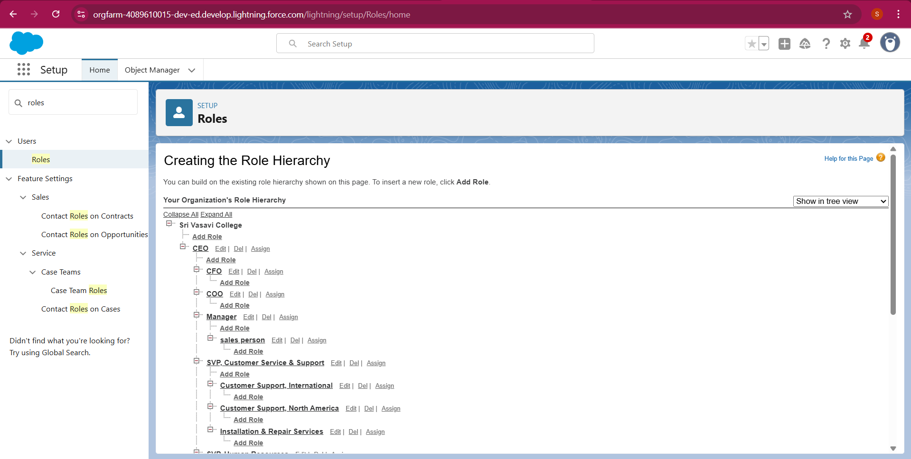

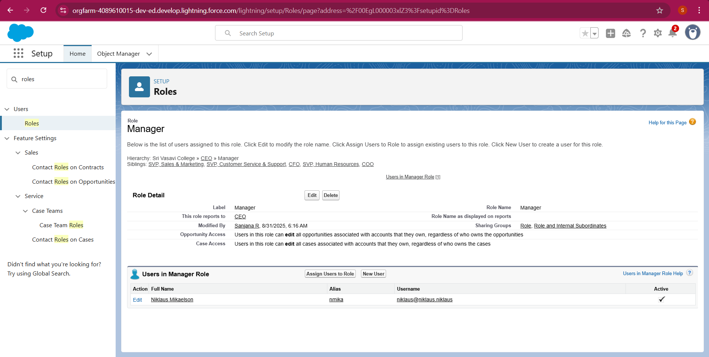

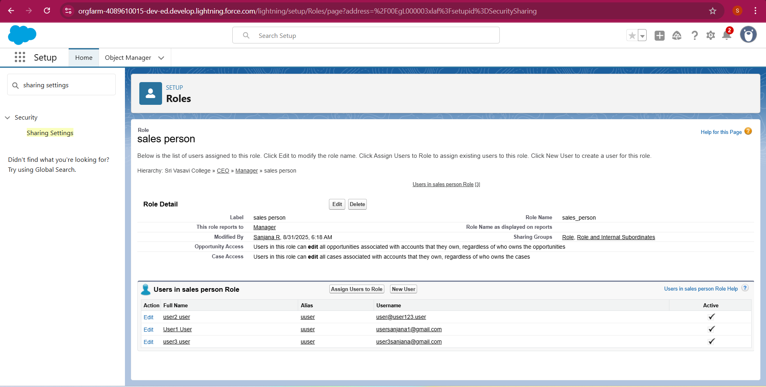

Creating user and anotherthree user’s

1. Role : sales person
2. User licence : Salesforce Platform
3. Profile : sales person

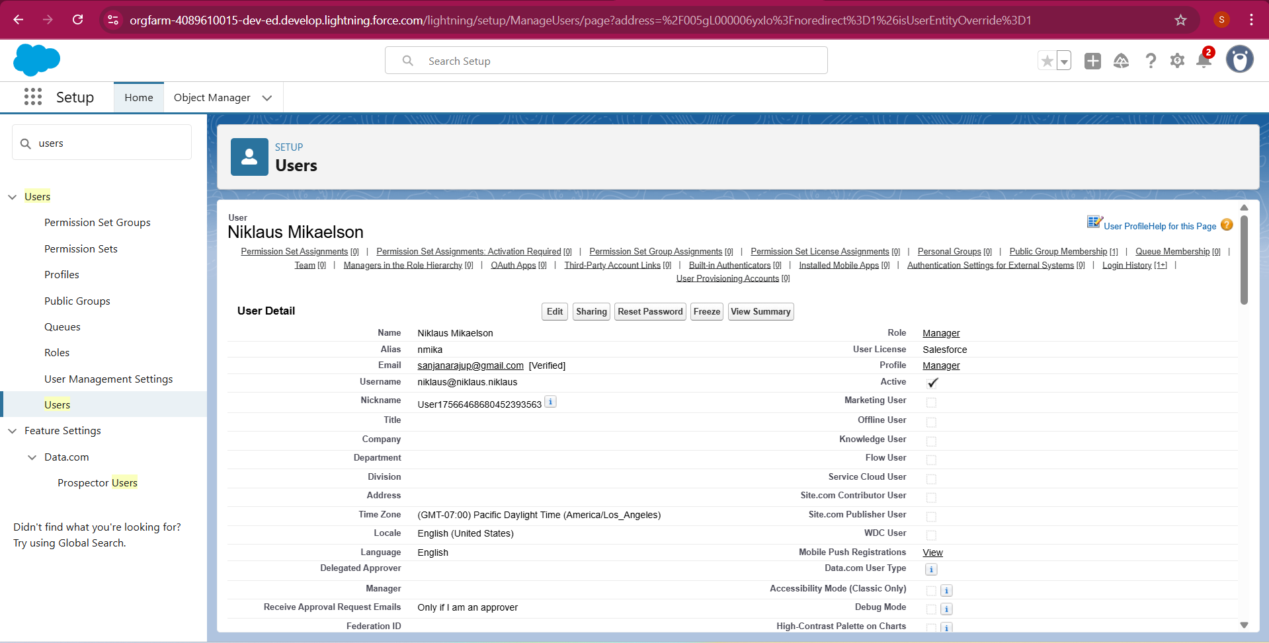

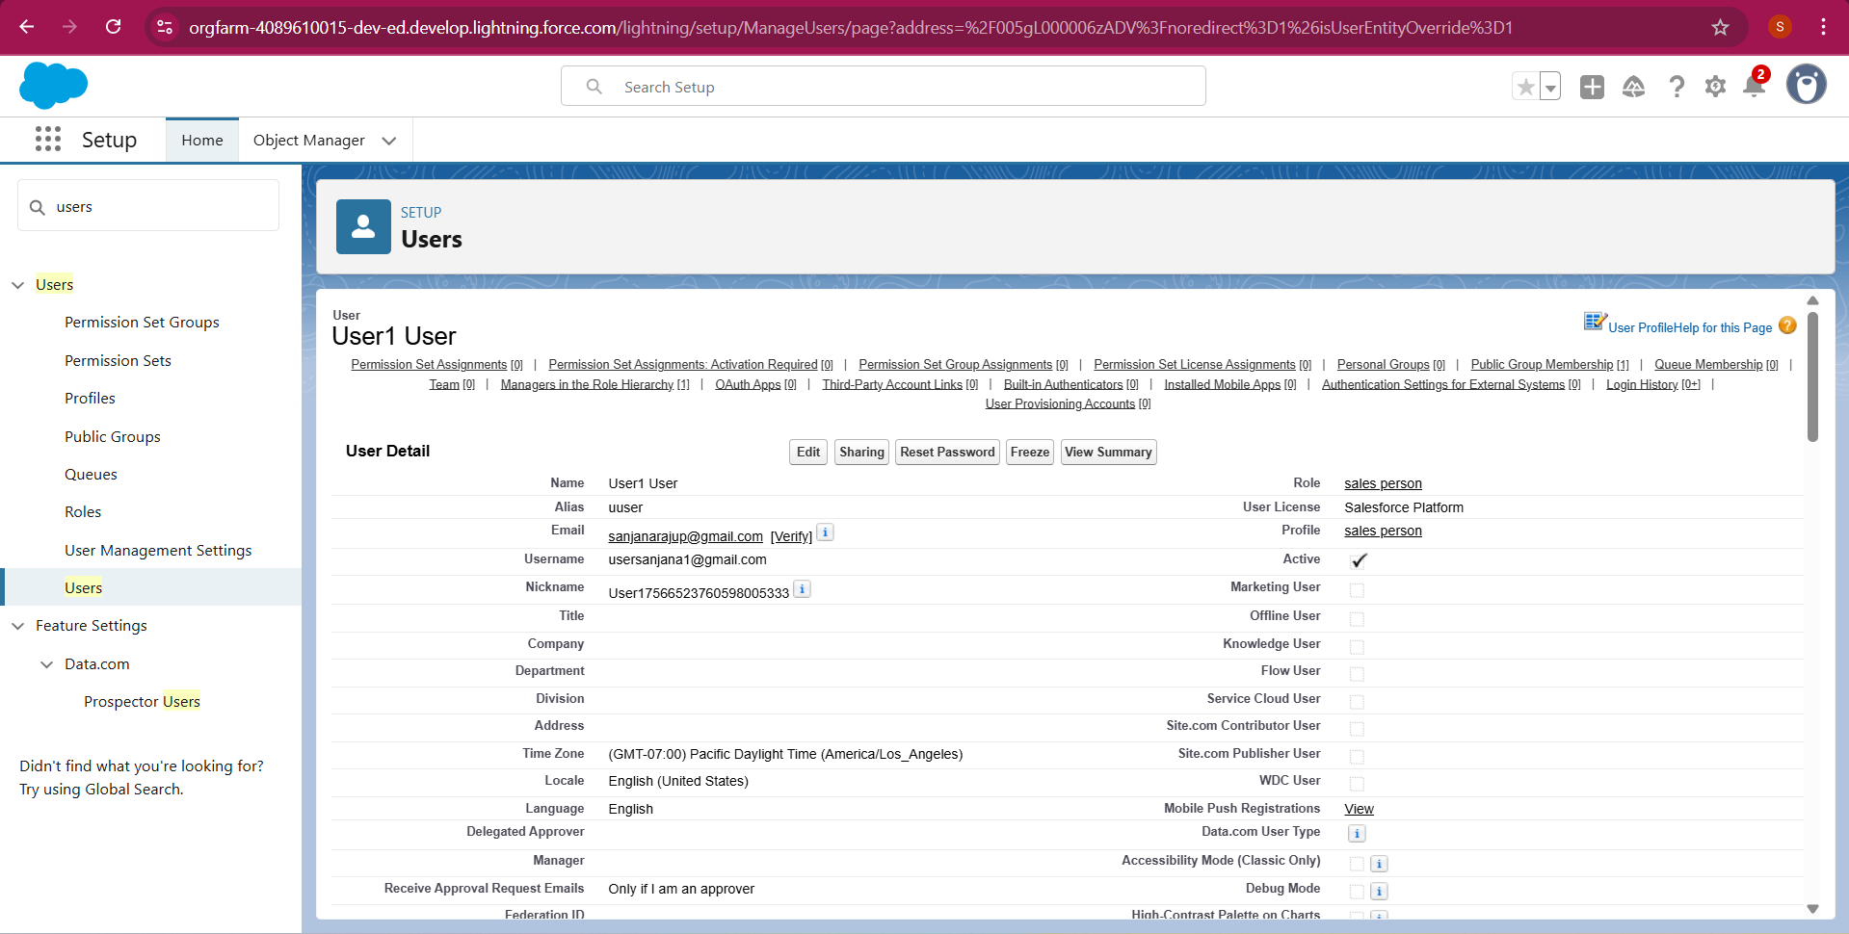

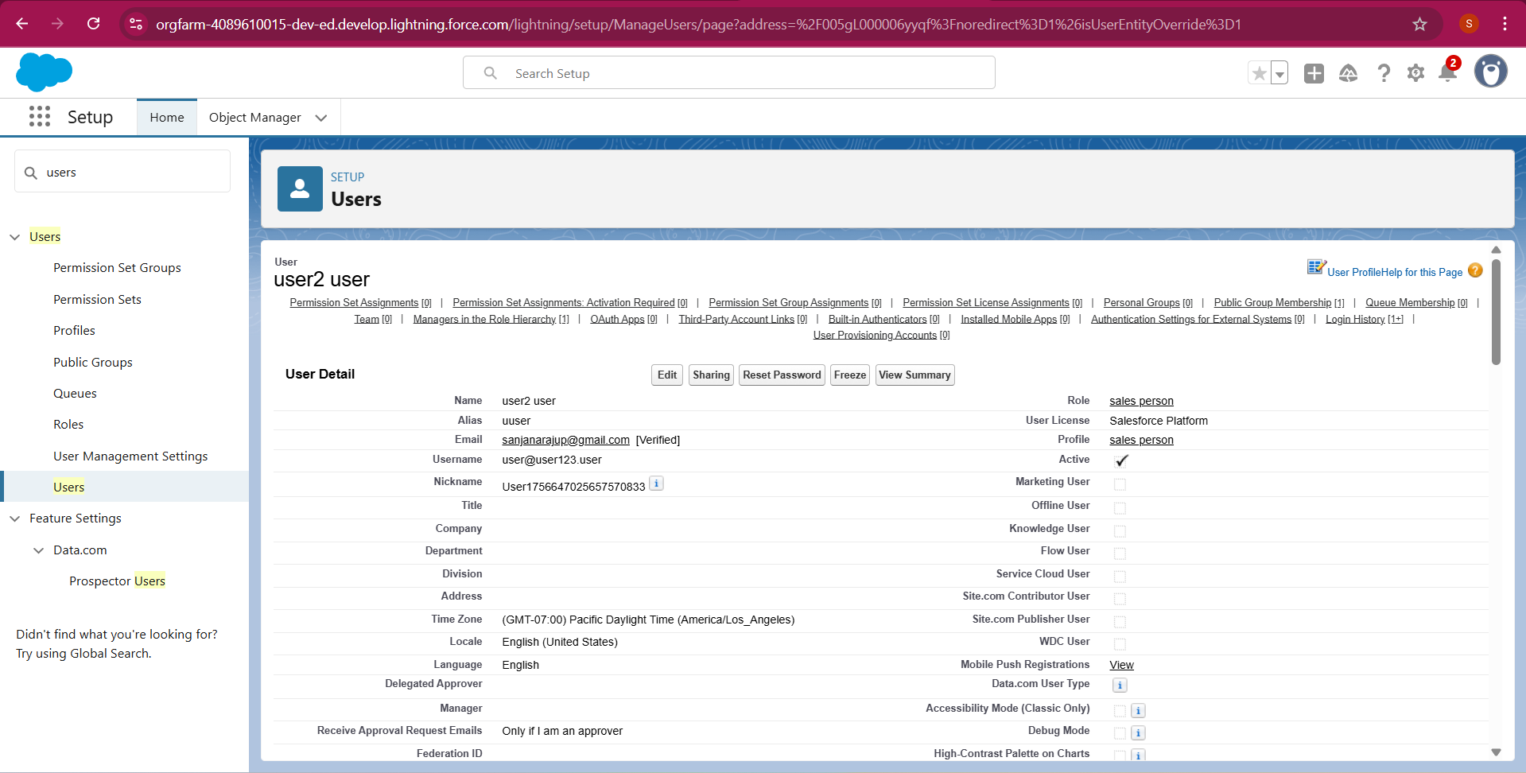

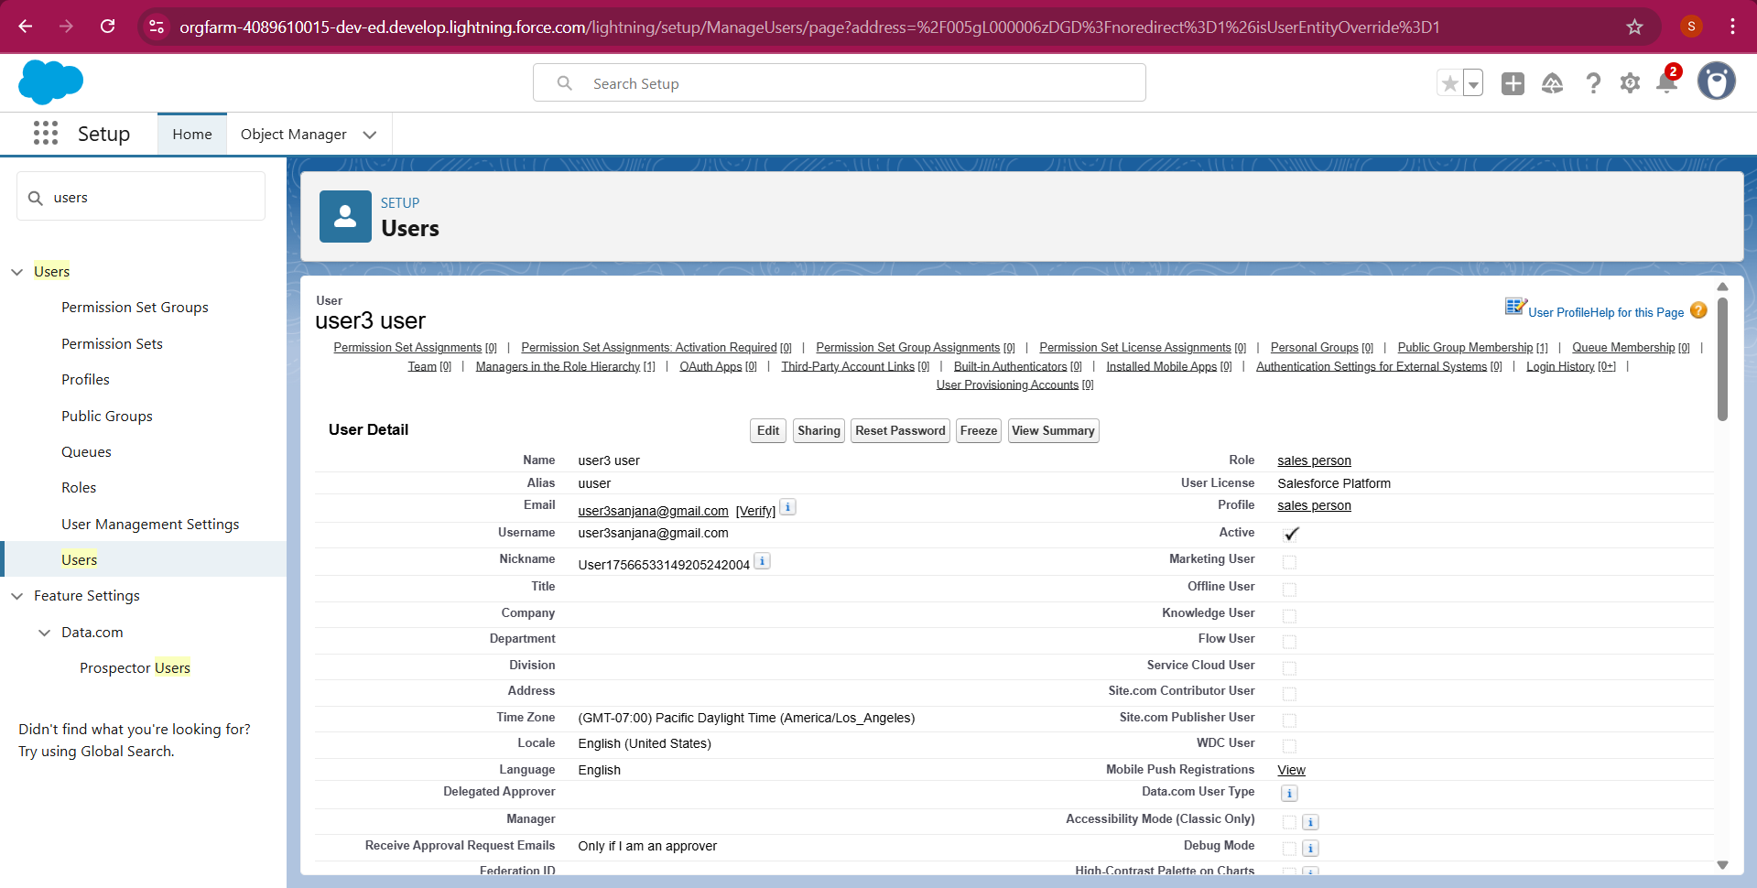

**Creating New Public Group**

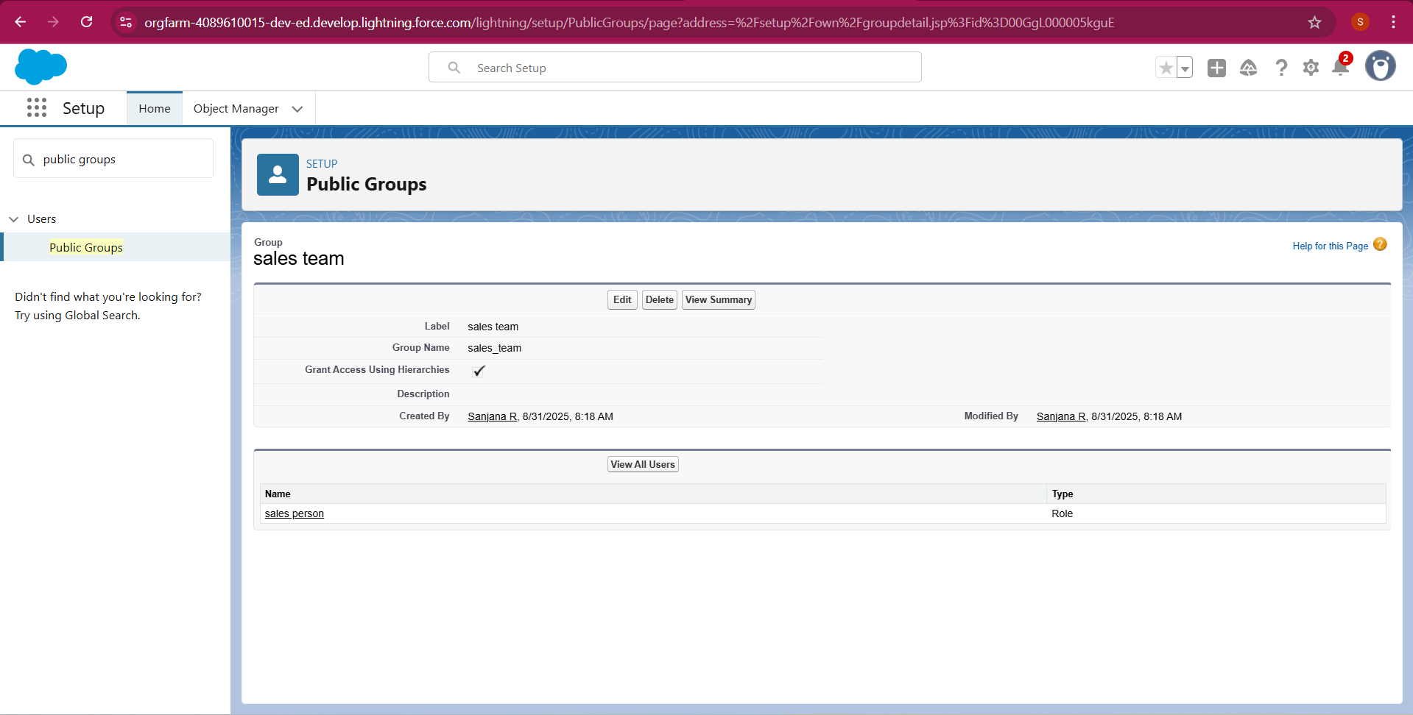

**Creating Sharing settings**

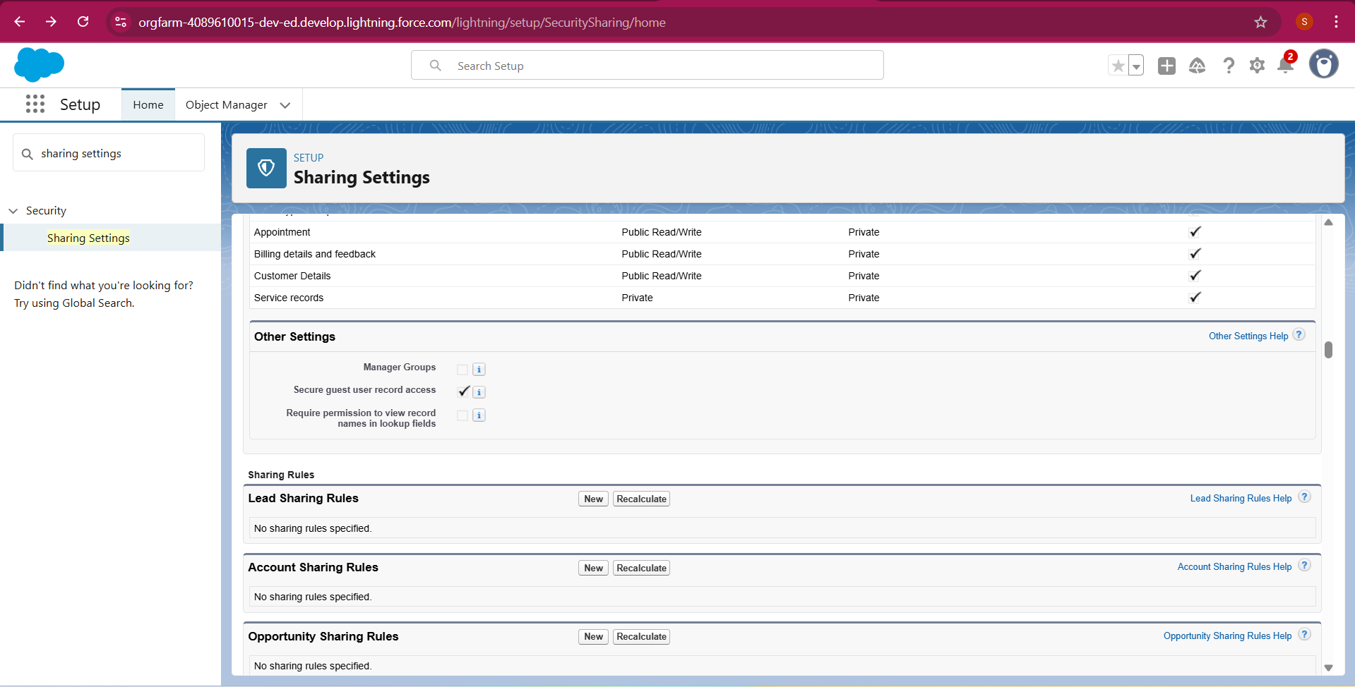

Sales person



**Flows**

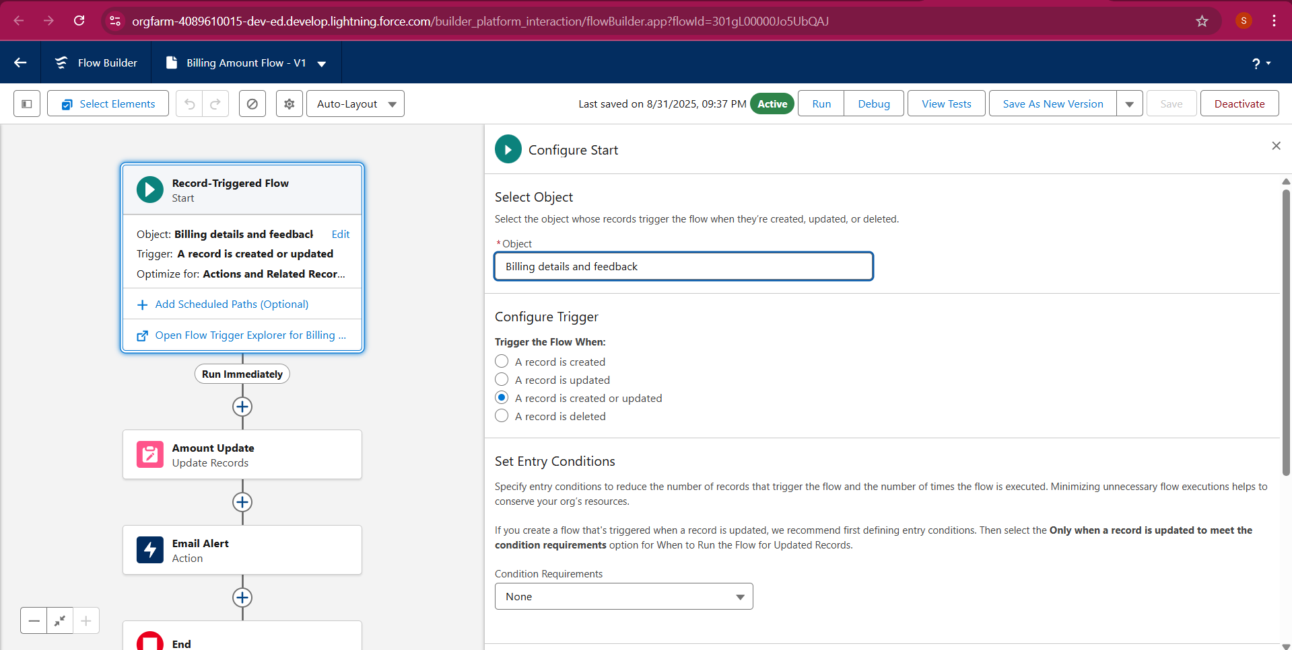

Another flow

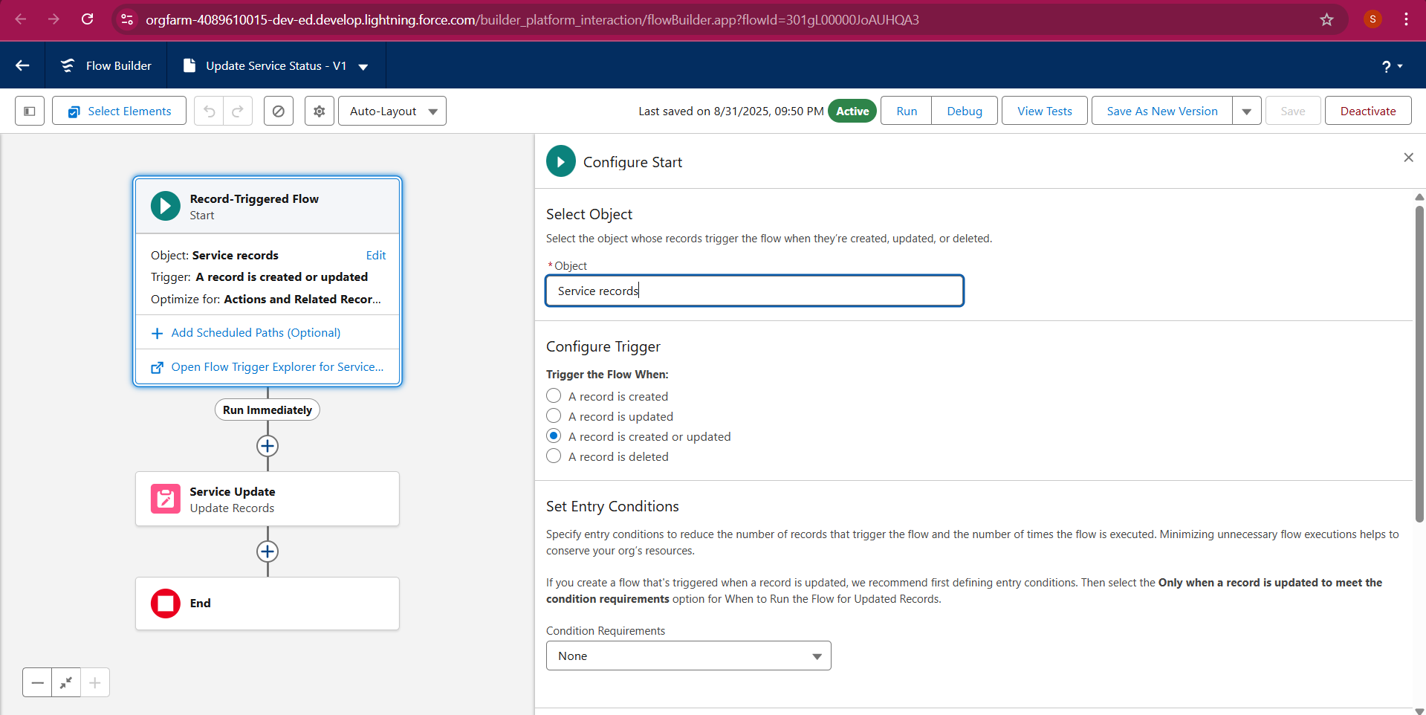

**Apex handler**

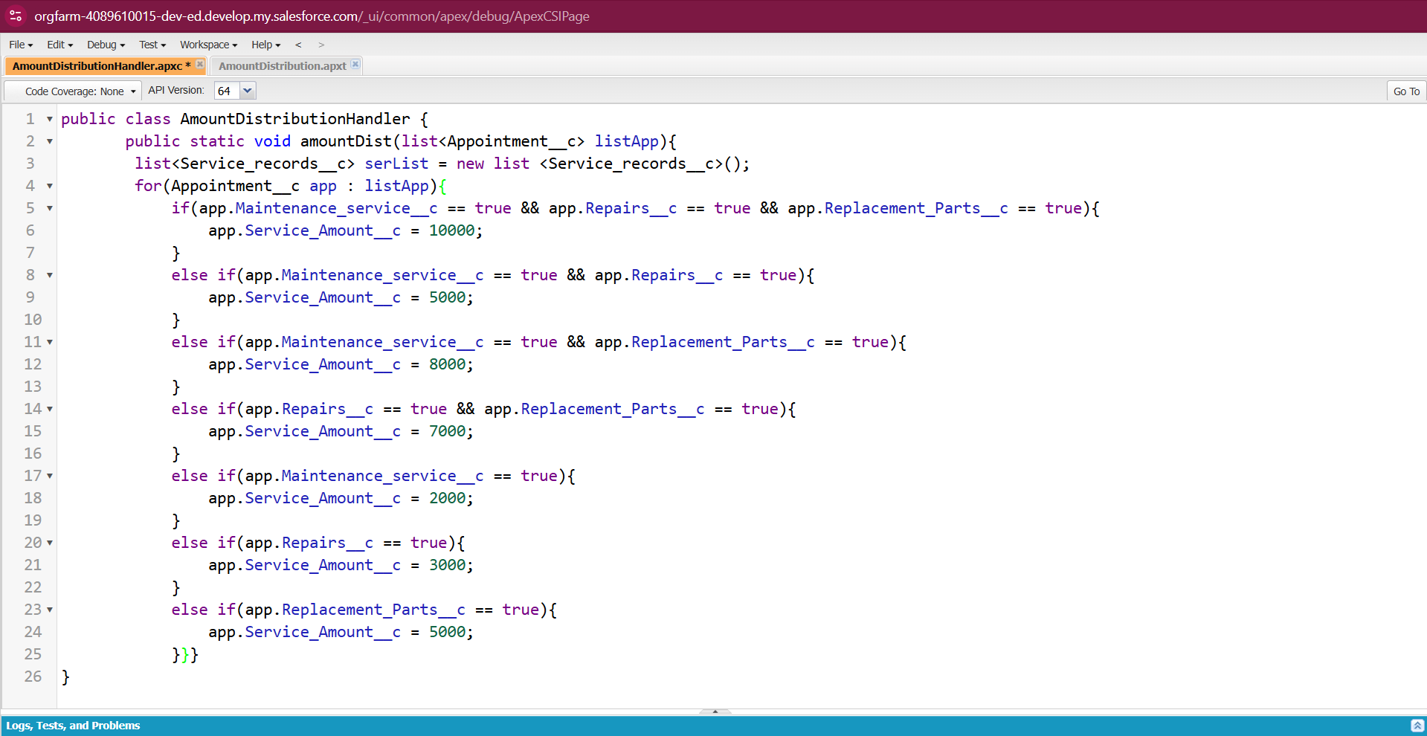

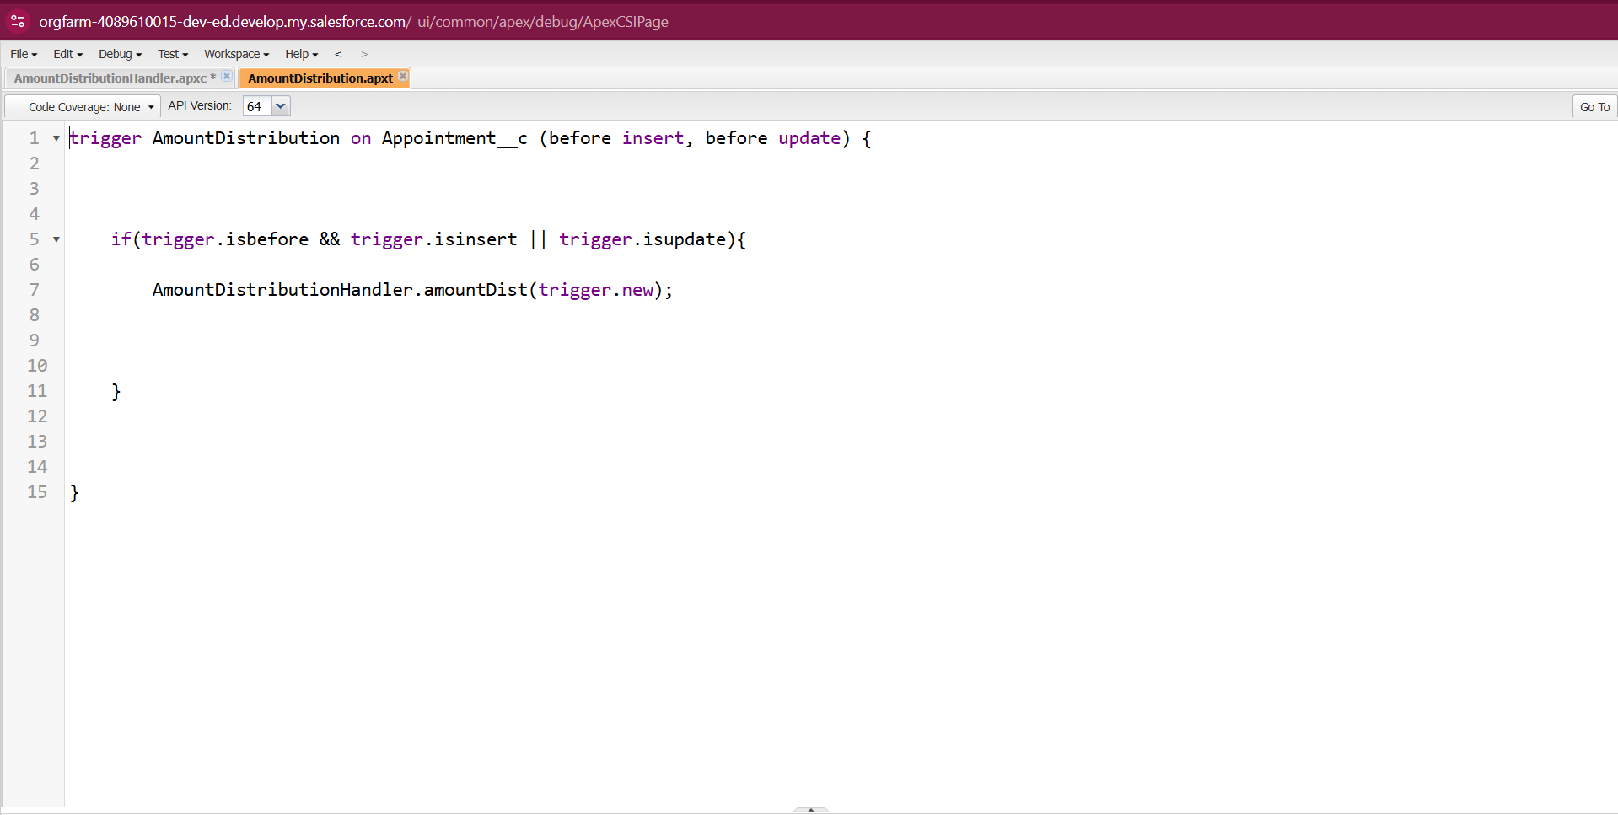

**reports**

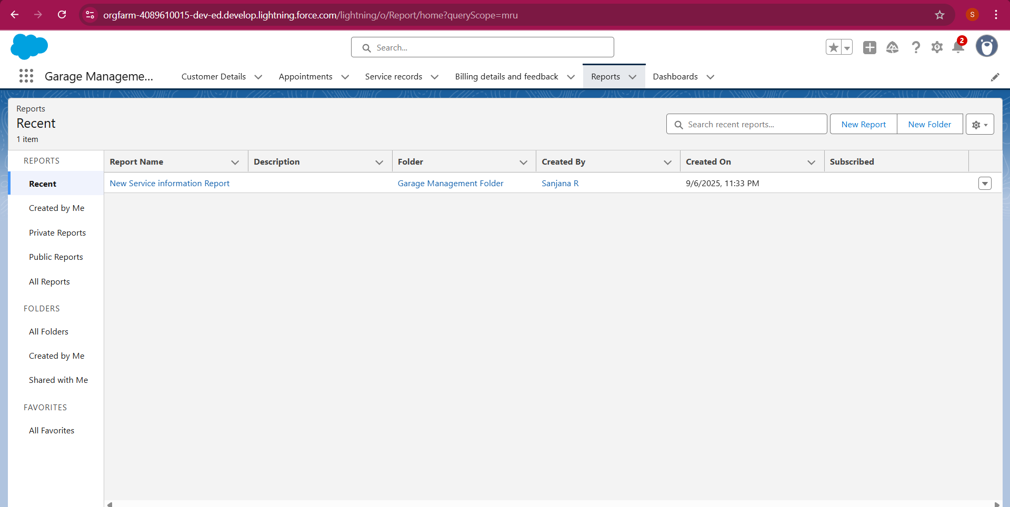

**Sharing a report folder**

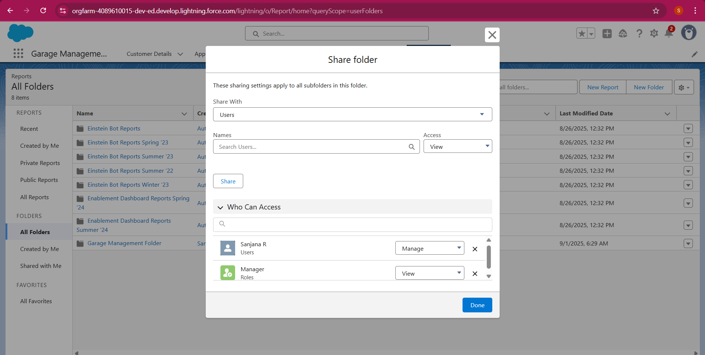

**Create Report Type**

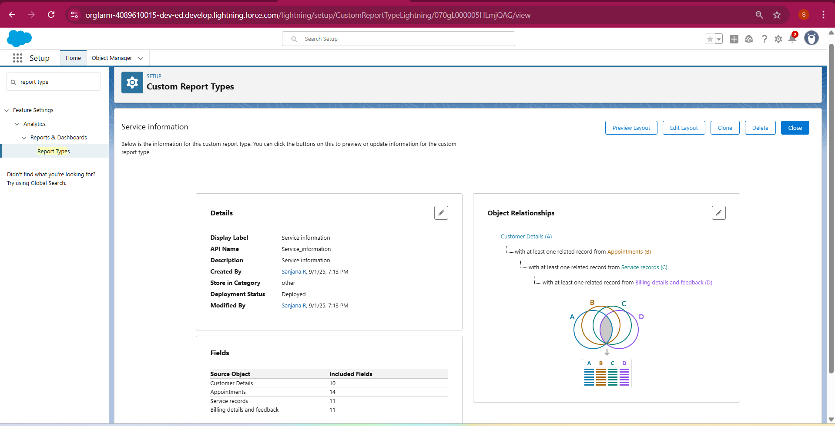

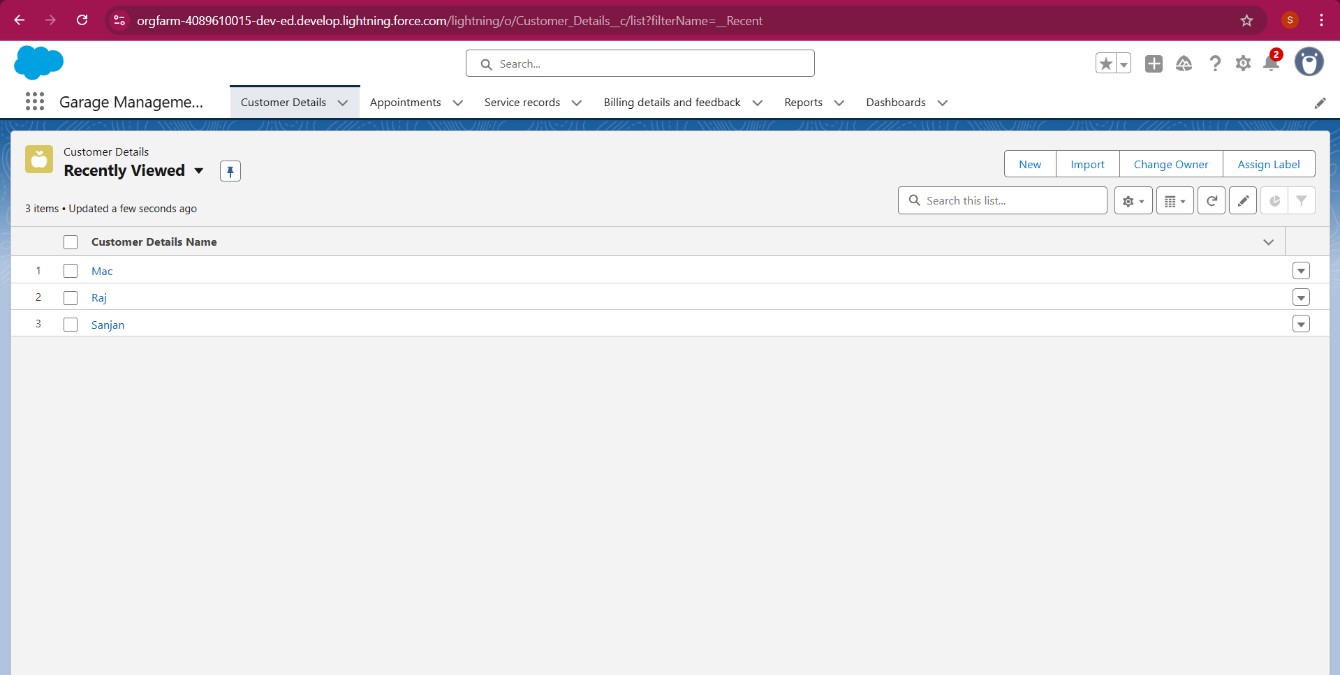

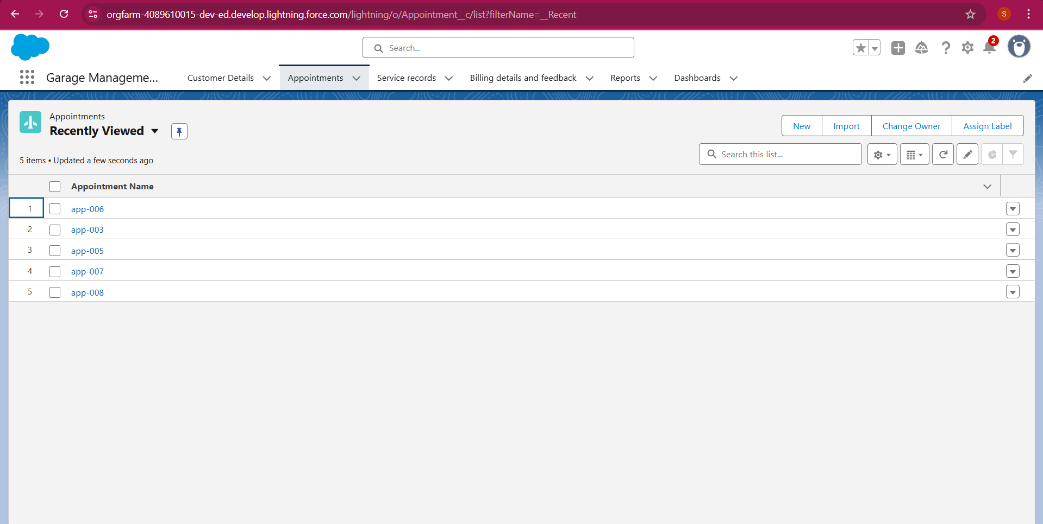

**Create Report**

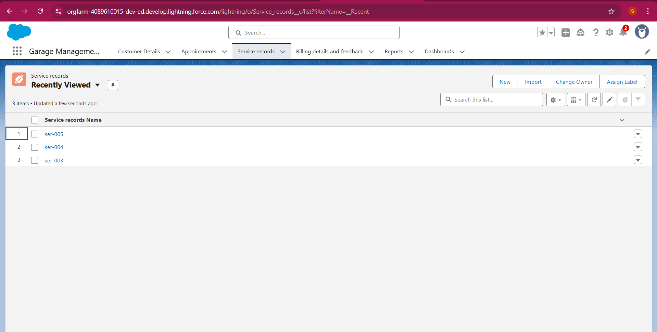

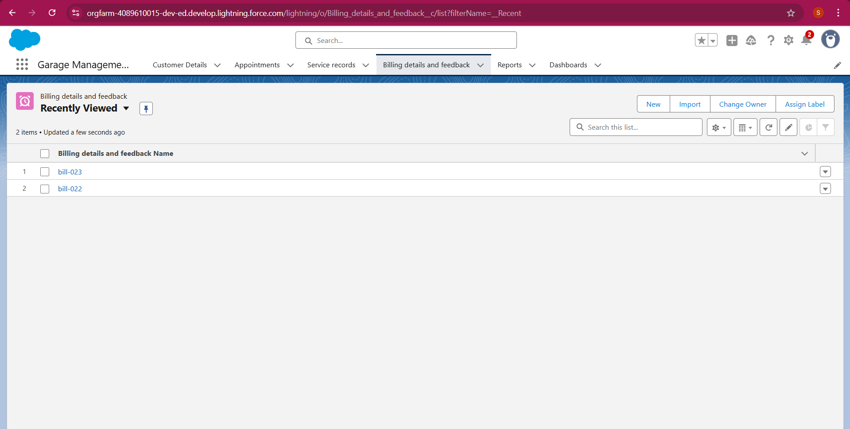

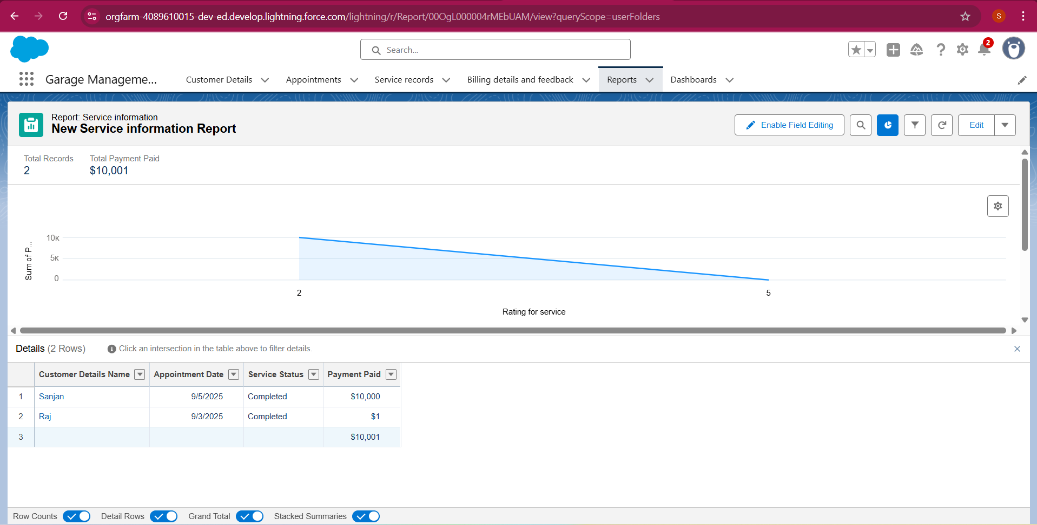

**Create Dashboard Folder**

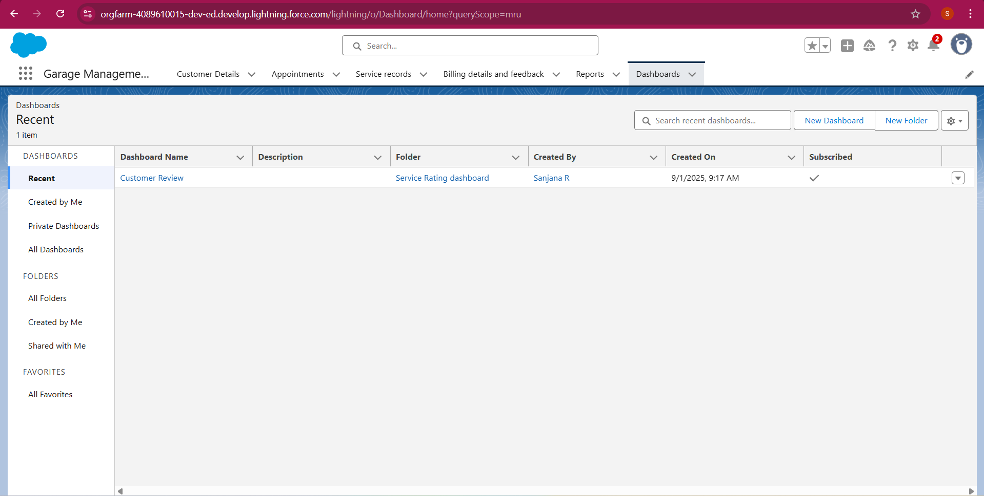

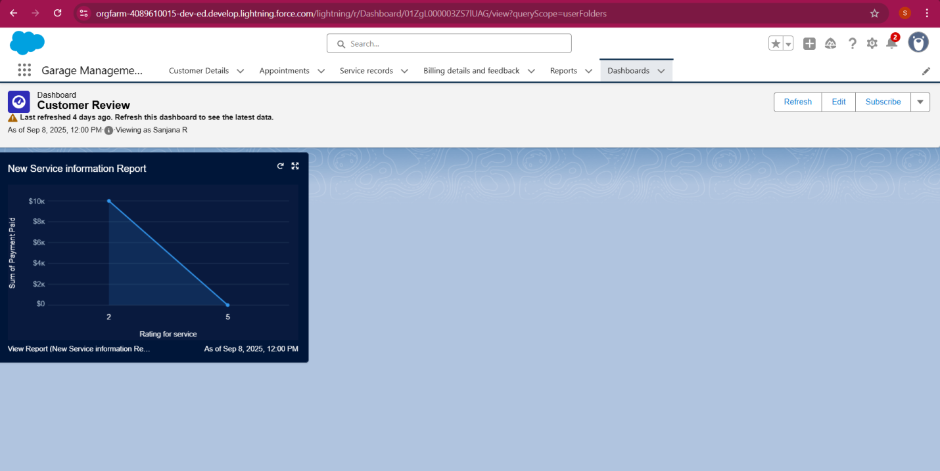

**User Adoption**

**New customer detail**

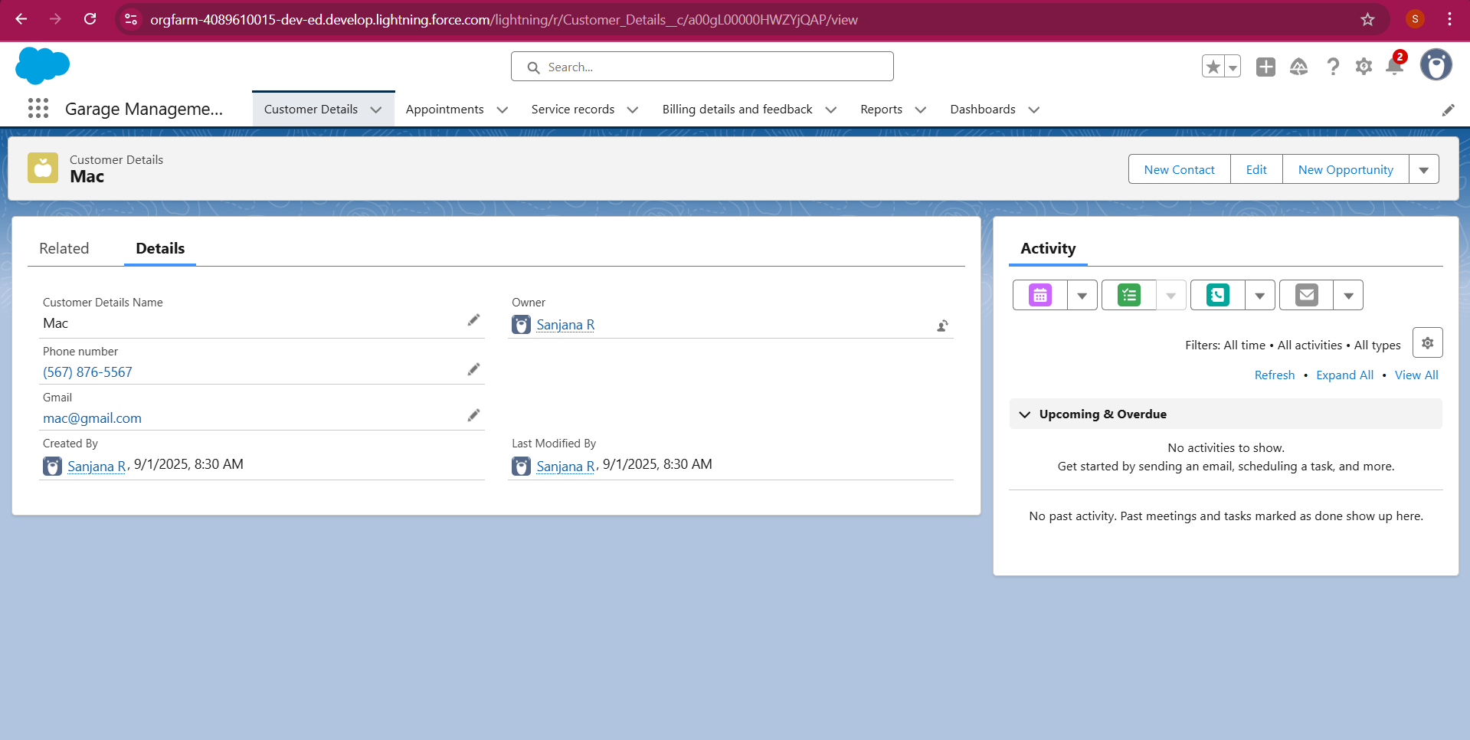

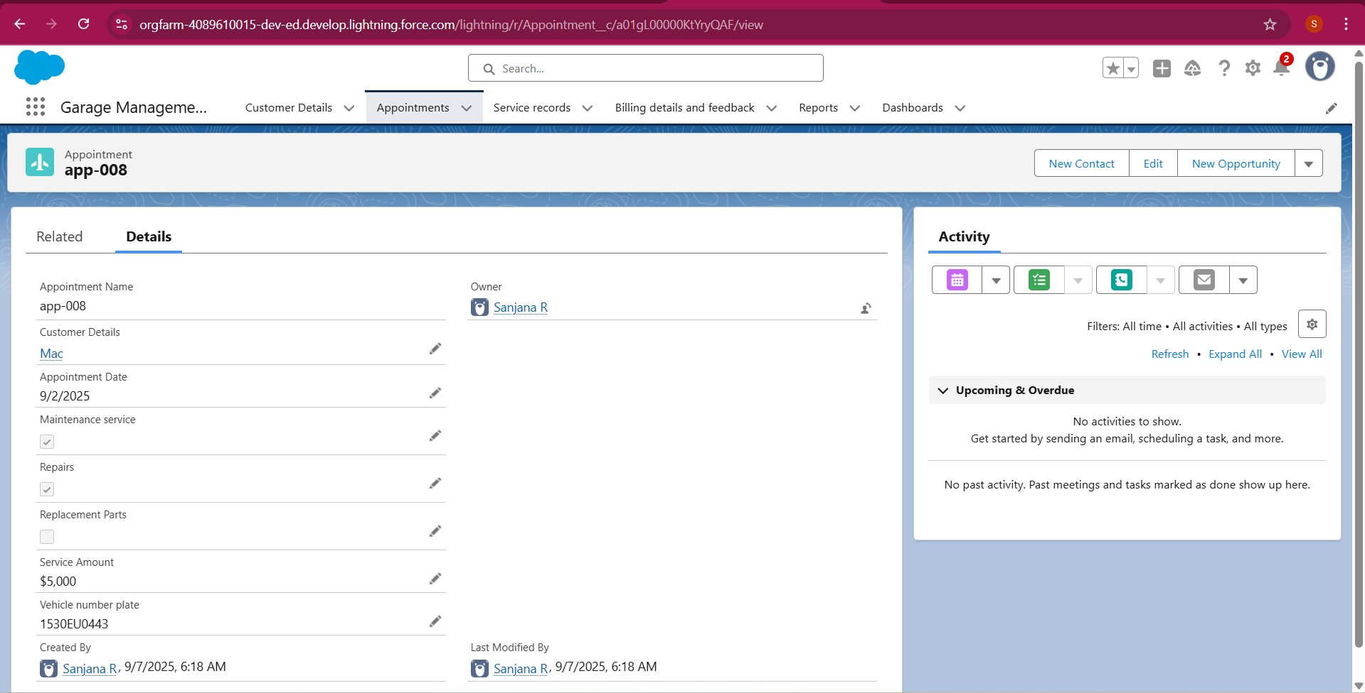

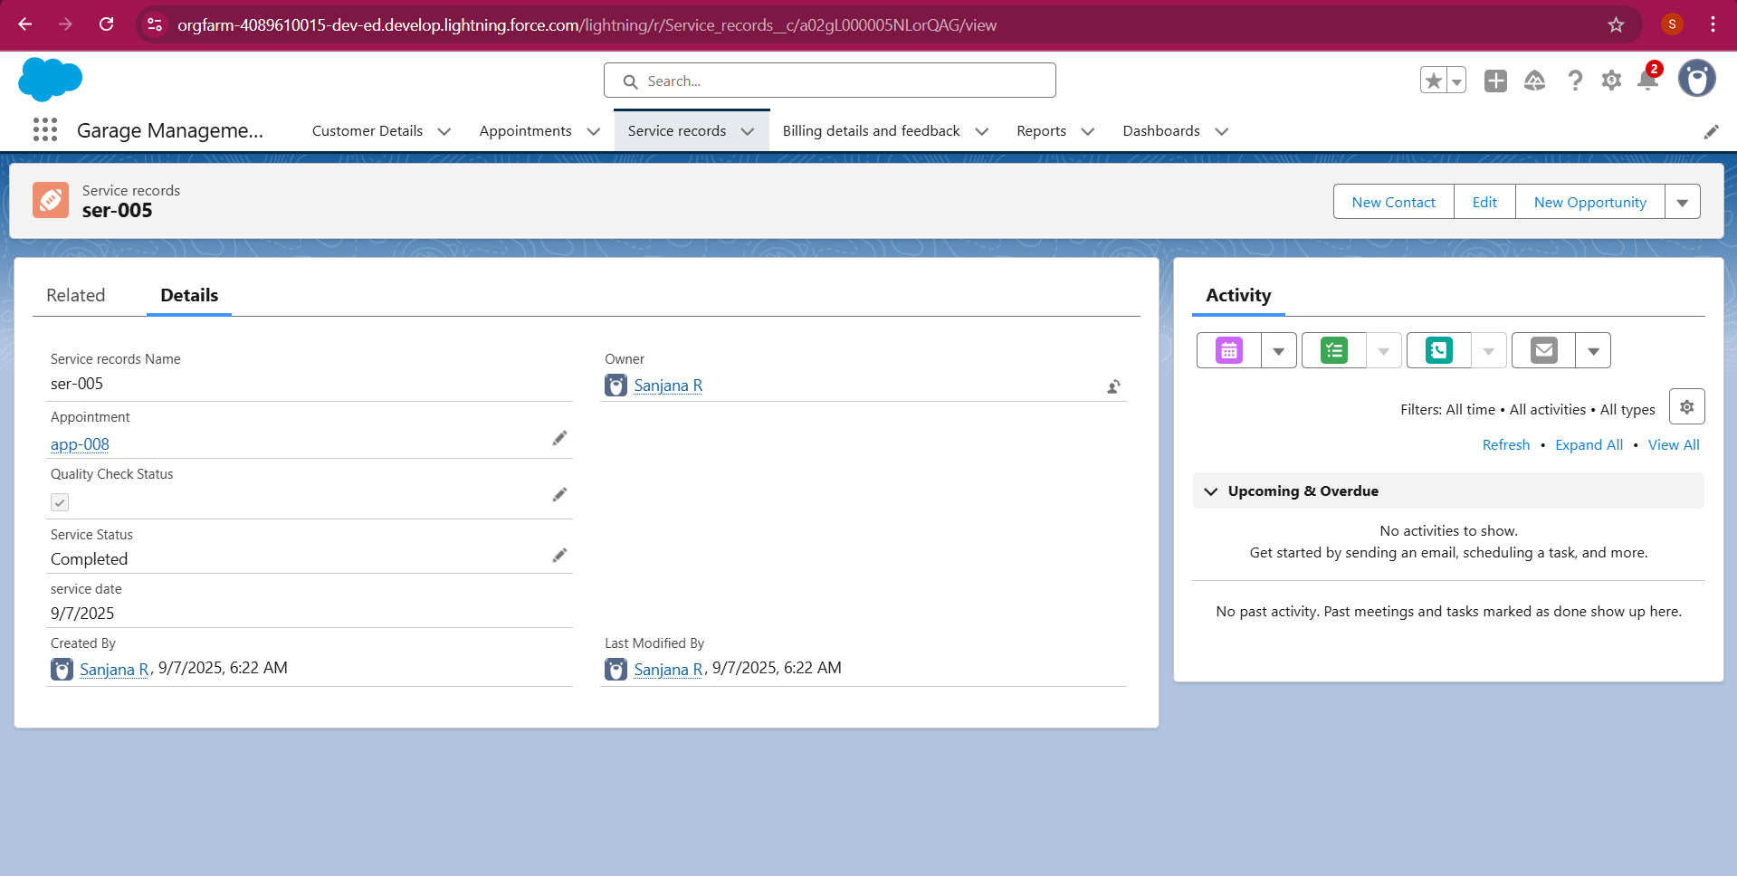

public class AmountDistributionHandler {

    public static void amountDist(list<Appointment__c>listApp){

        list<Service_records__c>serList = new list <Service_records__c>();

        for(Appointment__capp :listApp){

            if(app.Maintenance_service__c == true &&app.Repairs__c == true &&app.Replacement_Parts__c == true){

                app.Service_Amount__c = 10000;

            }

            else if(app.Maintenance_service__c == true &&app.Repairs__c == true){

                app.Service_Amount__c = 5000;

            }

            else if(app.Maintenance_service__c == true &&app.Replacement_Parts__c == true){

                app.Service_Amount__c = 8000;

            }

            else if(app.Repairs__c == true &&app.Replacement_Parts__c == true){

                app.Service_Amount__c = 7000;

            }

            else if(app.Maintenance_service__c == true){

                app.Service_Amount__c = 2000;

            }

            else if(app.Repairs__c == true){

                app.Service_Amount__c = 3000;

            }

            else if(app.Replacement_Parts__c == true){

                app.Service_Amount__c = 5000;

            }

    }

    }

}

Syntax For creating trigger :

The syntax for creating trigger is :

Trigger [trigger name] on [object name]( Before/After event)

{

}

1. Handler for the Appointment Object

Code:

trigger AmountDistribution on Appointment__c (before insert, before update) {

    if(trigger.isbefore&&trigger.isinsert || trigger.isupdate){

        AmountDistributionHandler.amountDist(trigger.new);

    }

}